Adjustable Rate Mortgage Calculator – User Guide

Objective:

Provide insights in both graphic and numerical form to illustrate the cash flow in an ARM with respect to its rates and rules.

Environment:

Developed on Qt with C++.

UI Demonstration:

* User Input

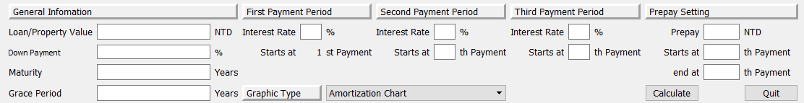

To be concise, the calculator will work as long as the user provides reasonable input. Detailed rules are as followed:

1. The inputs for grace, down payment, second, third period, and prepayment relevant blanks are optional and can be left blank.
2. The rates in second and third period will automatically copy the inputs from previous period if left blank, however, the program will show “ERR” message when a user assign 0 or invalid input to any rate and starting payment time.
3. Similarly, the mandatory inputs such as loan, maturity, and initial rate cannot be left in blank or any value no larger than 0.
4. If grace period is larger than term (maturity times 12), or second starting payment time is larger than third starting payment time, the program will see it as invalid inputs and therefore no cash flow and graphics will be displayed.

* 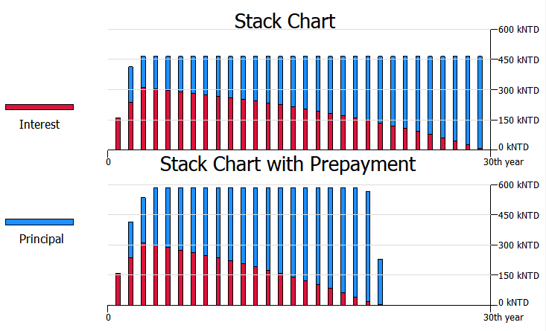Graphics and Legend

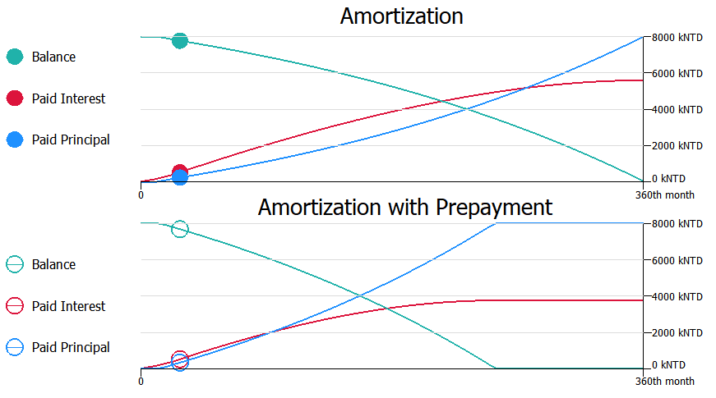

If all the inputs are valid, program will display two kinds of figures.

1. The Amortization figure on the top side shows and the accumulated paid interest in red line, accumulated paid principal in blue line, and remained balance in green line as legend suggests. And the figure of Amortization with prepayment on the bottom side displays result with the same method.
2. The Stack Chart on the top side shows the payment structure ANNUALLY. The red stack bar represents interest while the blue bar stands for principal paid. Similarly, the stack chart with prepayment is placed on the bottom side. As we can see here the outstanding balance meets zero early due to prepayment made during amortization.
3. 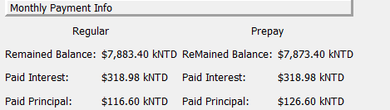When viewing Amortization chart, the dots will show up accordingly when the user clicks one of the row in the period tabs. It discloses the accumulated interest and principal at the moment and shows how much balance is remained.

* Numerical Tabs

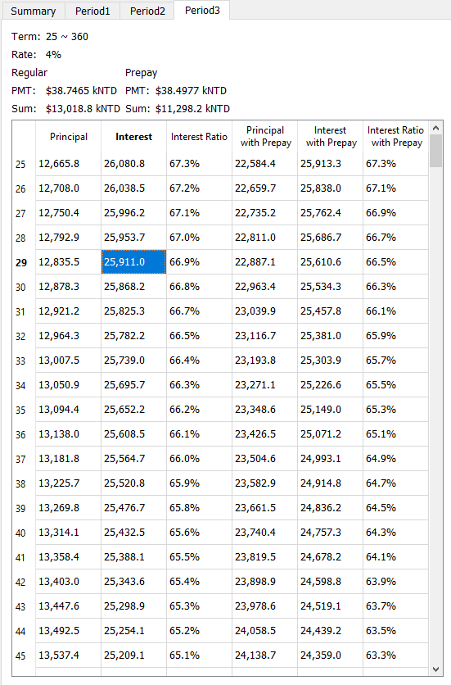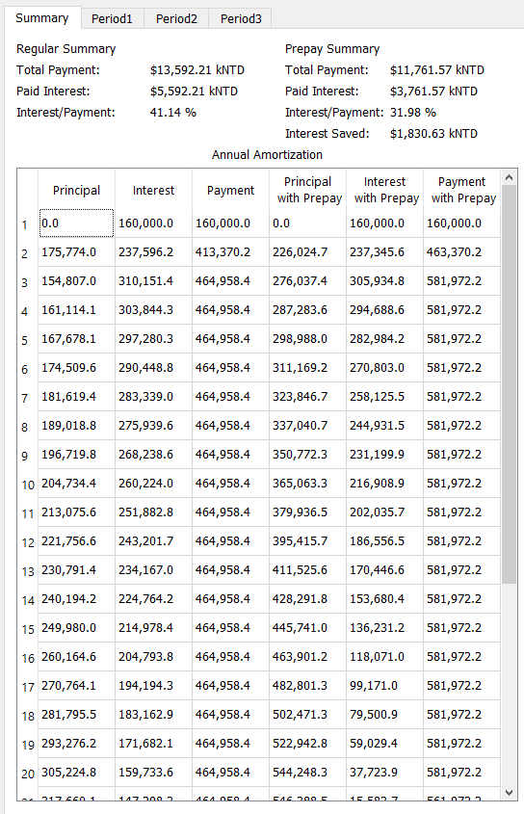

1. The summary tab displays all the annual payment for interest, principal. Also, it shows the total summation of paid interest and principal during the mortgage life time and reveals the weight of interest.
2. The period tabs show the general information in a payment period and detailed inform for each payment made.